IDEATION PHASE

Brainstrom & Idea Prioritization Template

|  |  |
| --- | --- |
| Date | 28 September 2022 |
| Team ID | PNT2022TMID10436 |
| Project Tittle | Web Phishing Detection |
| Maximum mark | 4 Marks |

**Brainstorm & Idea Prioritization :**

Brainstorming provides a free and open environment that encourages everyone within a team to participate in the creative thinking process that leads to problem solving. Prioritizing volume over value, out-of-the-box ideas are welcome and built upon, and all participants are encouraged to collaborate, helping each other develop a rich amount of creative solutions

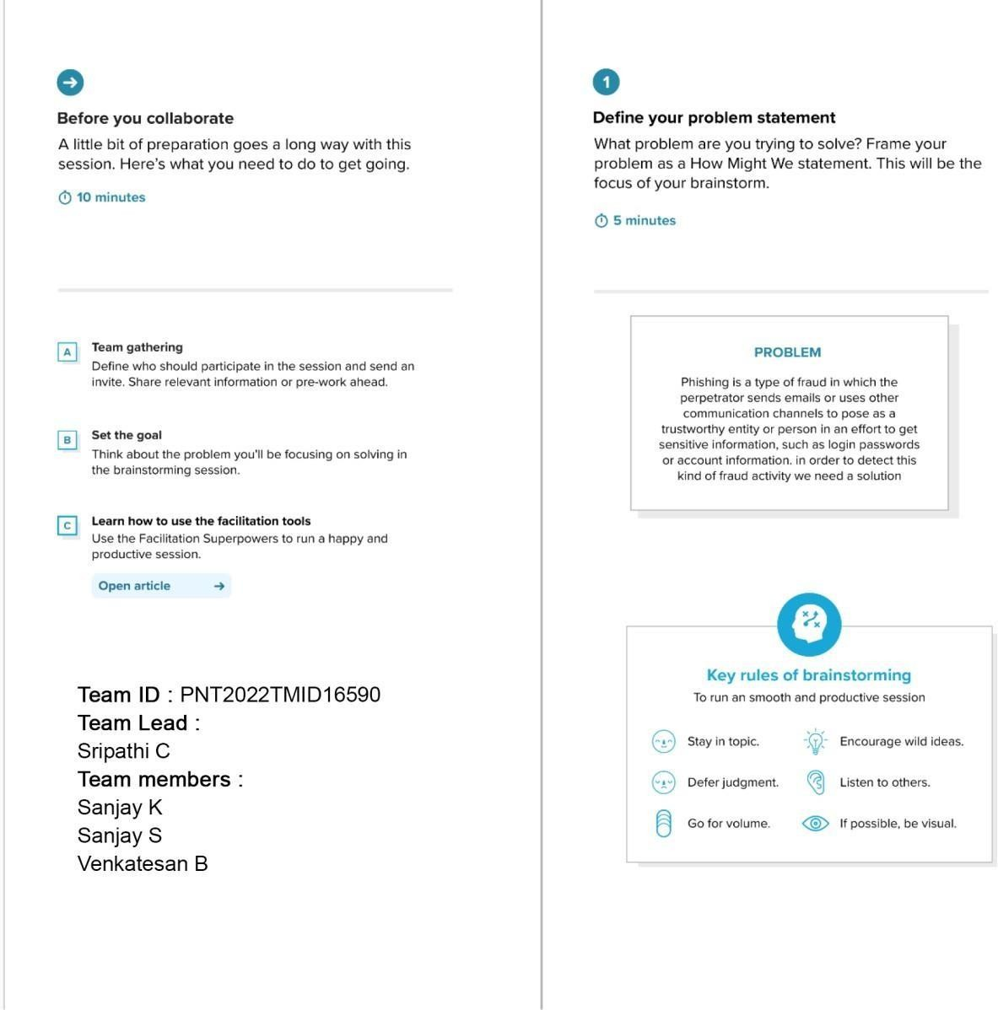

**Team Leader:** Sivanesan

**Team member:** Russel

**Team member:** Mohammed Nishad

**Team member:** Pranav

Sivanesan Mohammed Nishad

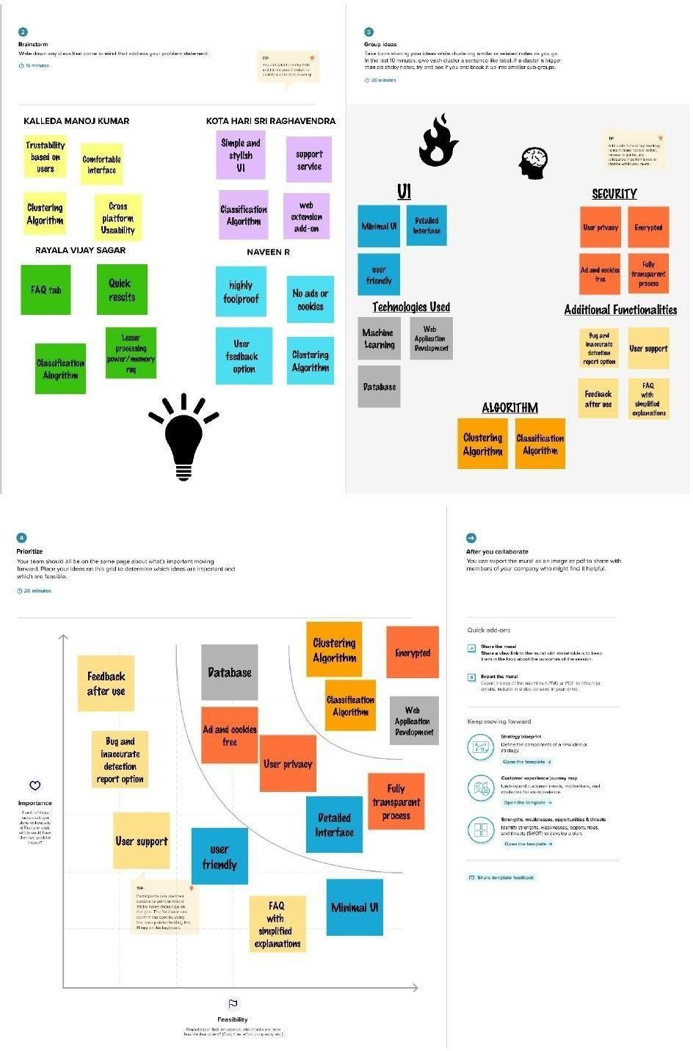

Russel Pranav